A Sprint is a fixed period in which the team completes a defined set of project tasks.
An Epic is a major project area divided into smaller user stories that can be completed within sprints.
A Story is a small, independently trackable task within an Epic.
A Story Point represents the relative effort required to complete a story.
- Very Easy task
- Normal task
- Moderate task
- Difficult task

Story Point Scale: 1 – Very Easy | 2 – Normal | 3 – Moderate | 5 – Difficult

Gathering Data (USN1) 2
Loading Data(USN2) 1

Handling Missing Values(USN3) 3
Creating Fields(USN4)3
Handling Inconsistency in Data(USN5)3

Bar Chart(USN6) 2
Pie Chart(USN7) 2
Line Chart(USN8) 2
Map(USN9) 4

Developing Dashboard(USN10) 5

Developing Story(USN11) 5

Total story Point in Sprint 2= 2+2+2+4+5+5=20

Total story Points= 12+20=32
No of Sprints= 2

16(Story Points per Sprint)

Planning Logic — Implement Client Script & UI Policy (Incident)
The implementation is planned across two sprints: first configuring the Incident UI Policy and UI Policy Action, then implementing Client Scripts and completing configuration testing.
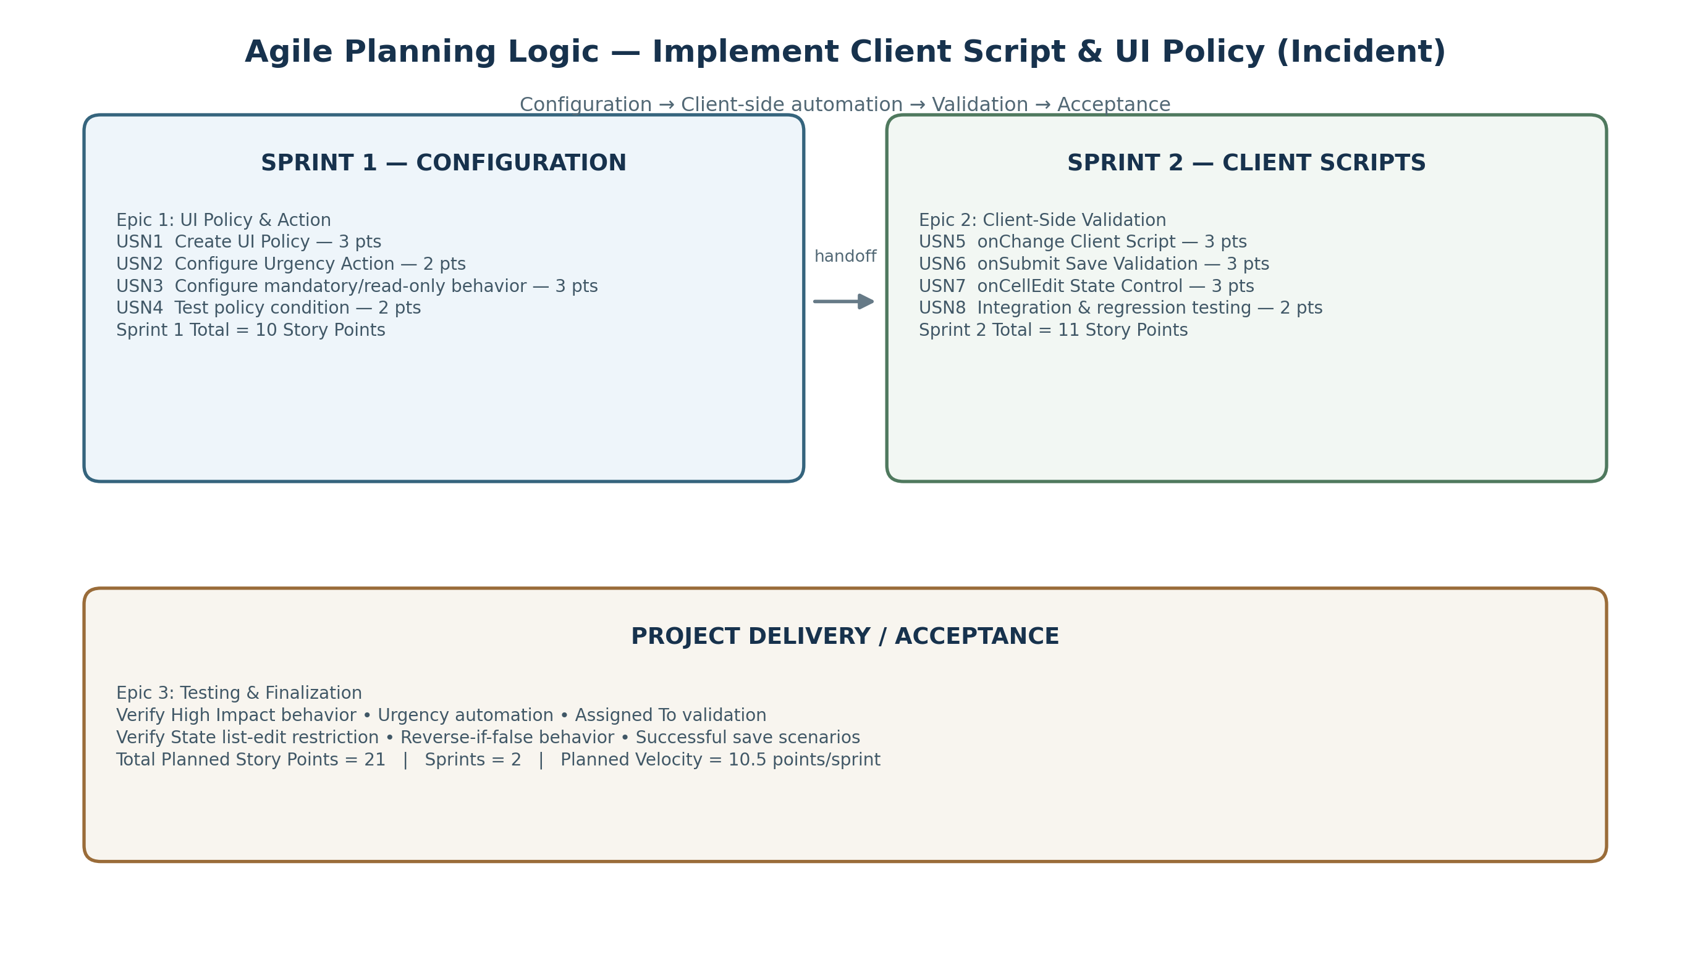
Sprint 1 — UI Policy Configuration
Epic / Story | User Story / Task | Story Points | Acceptance / Output
Epic 1 / USN1 | Create UI Policy on Incident for High Impact condition | 3 | Policy activates on the configured Incident condition.
Epic 1 / USN2 | Create UI Policy Action to control Urgency | 2 | Urgency follows the configured mandatory/read-only behavior.
Epic 1 / USN3 | Configure conditional field behavior | 3 | Required fields and editable/read-only states change correctly.
Epic 1 / USN4 | Test UI Policy and reverse-if-false behavior | 2 | Behavior reverses correctly when the condition becomes false.
Sprint 1 — UI Policy Configuration Total Story Points = 10
Sprint 2 — Client Scripts & Validation
Epic / Story | User Story / Task | Story Points | Acceptance / Output
Epic 2 / USN5 | Create onChange Client Script | 3 | Impact change triggers the required Incident field update.
Epic 2 / USN6 | Create onSubmit Client Script (Save Validation) | 3 | Invalid Incident cannot be saved; clear validation is shown.
Epic 2 / USN7 | Create onCellEdit Client Script | 3 | Direct State list editing is blocked as configured.
Epic 2 / USN8 | Integration and regression testing | 2 | All client scripts and UI policies work together without conflict.
Sprint 2 — Client Scripts & Validation Total Story Points = 11
Velocity Calculation
Total Story Points = 10 + 11 = 21
Number of Sprints = 2
Planned Velocity = 21 / 2 = 10.5 Story Points per Sprint
Project Milestone Alignment
Milestone 1: Create UI Policy on Incident
Milestone 2: Create UI Policy Action – Urgency
Milestone 3: Create onChange Client Script
Milestone 4: Create onSubmit Client Script (Save Validation)
Milestone 5: Create onCellEdit Client Script
Milestone 6: Testing the Configuration
Conclusion: Demonstrate a controlled and validated Incident workflow.

